Standard Operating Procedures for

[Tour Operator Name]

9 Point Checklist for Gold Standard Recognition Program

Instructions: The below is a sample template to guide Tour Operators in developing the Standard Operating Procedures (SOP) to obtain Gold Standard Recognition. Tour Operators must complete sections in red and customize template to suit their operations. Once all sections are completed the plan must be submitted to qualityassurance@belizetourismboard.org

Name of Tour Operator Company______________________________
Tour Operator license #______________________________________
Declaration:
I hereby certify that all information provided in this application and plan is true, accurate and complete to the best of my knowledge. I have not withheld any information and understand any falsification is illegal and will disqualify this application.
Print Name of Gold Standard Manager_________________________________

Signature of Gold Standard Manager___________________________________

Print Name of General Manager/Owner________________________________

Signature of General Manager/Owner__________________________________

Date: _________________

-------------------------------------------------------------------------------------------------------------------------

1) Appoint a Tourism Gold Standard Manager
- Contact information of the appointed Gold Standard Manager
  - Name________________________________________
  - Phone________________________________________
  - Email_________________________________________
- Name of Alternate Gold Standard Manager
  - Name__________________________________________
  - Phone__________________________________________
  - Email___________________________________________

- Duties and responsibilities of the Gold Standard Manager
- Ensure that all tour guides have done the BTB training sessions
- Ensure that all tour guides know the procedures on how to handle a symptomatic case.
- Ensure that all logs are being followed on each tour.
- Conduct spot checks on tours to ensure all protocols are being followed.
- Ensure all guides have Personal Protective Equipment and cleaning and sanitizing equipment
- Liaise with Ministry of Health on any symptomatic employee or guest and provide any logs necessary for contact tracing
- Ensure that Tour Operator’s SOPs are reviewed and modified as necessary
- Implement corrective actions when staff and guests are non-compliant with protocols
- List Others: (insert any additional duties/responsibilities assigned but not captured above)
- ____________________________________________________________________________________________________________________________________________________________________________________________________________________________________________________________________________________________________________________________________________________

- The program manager and alternate have completed the BTB trainings for Tour Operators. The dates of training done by Gold Standard Manager and Alternate are recorded on the training log below:
    - For reference click here for link to training videos
Training | Dates for training attended by Program Manager | Dates for training attended by Alternate Program Manager
 | Insert dates attended in this column | Insert dates attended in this column
 | Insert program manager signature here | Insert alternate program manager signature here

2) Implement Monitoring and Reporting
Monitoring
  - Employee checks:
    - If employee is sick, he/she should not come to work and report to Program Manager.
    - Tour guide and employee’s temperature will be checked every day before entry on to the property or before departing to tour. Any temperatures exceeding 100.4 F is considered a fever.
    - If a fever is detected, the employee/tour guide will not be allowed in property or allowed to continue tour. The response plan will be activated and symptoms/actions will be logged in COVID-19 symptomatic log.
    - Every tour guide and employee will be asked the following questions:
      - Have you been in close contact with a suspected or confirmed case of COVID 19?
      - Are your experiencing a cough, shortness of breath or sore throat
      - Have you had a fever in the last 48 hours?
      - Have you had a loss of smell or taste?
      - Have you had any vomiting or diarrhea in the last 24 hours?
      - Does anyone in your immediate household present these symptoms?
    - If multiple answers are yes, the employee will be isolated and the response plan will be activated.

  - Guests
    - All guest’s temperatures will be taken before going on tour. Any temperatures exceeding 100.4 F is considered a fever and this will be logged in the COVID-19 Symptomatic log.
    - Any symptomatic guest will be isolated and the response plan will be activated.
  - Vendors and supplier’s temperature will be taken prior to entry into office. Any temperatures exceeding 100.4 F is considered a fever and this will be logged in the COVID-19 Symptomatic log. No outside visitors will be allowed without being checked.
  - Security personnel and all staff will report any observations of guests and staff that appear to be symptomatic or non-compliant with protocols.
  - All will be observed for the following symptoms and reported:
    - Less serious symptoms
      - Fever
      - Dry cough
      - Headache
      - Conjunctivitis
      - Tiredness (prior to tour activities)
      - Loss of taste and smell
      - A rash on skin or discoloration of fingers or toes.
      - Aches and pains
      - Sore throat
      - Diarrhea
    - Serious symptoms
      - Difficulty breathing or shortness of breath
      - Chest pain or pressure
      - Loss of taste and smell
    - Any observation of symptoms will be communicated via the Ministry of Health and Wellness (MOHW) hotline 0-800-664- 2273.
    - For contact tracing queries at the district level the following numbers below can be utilized:
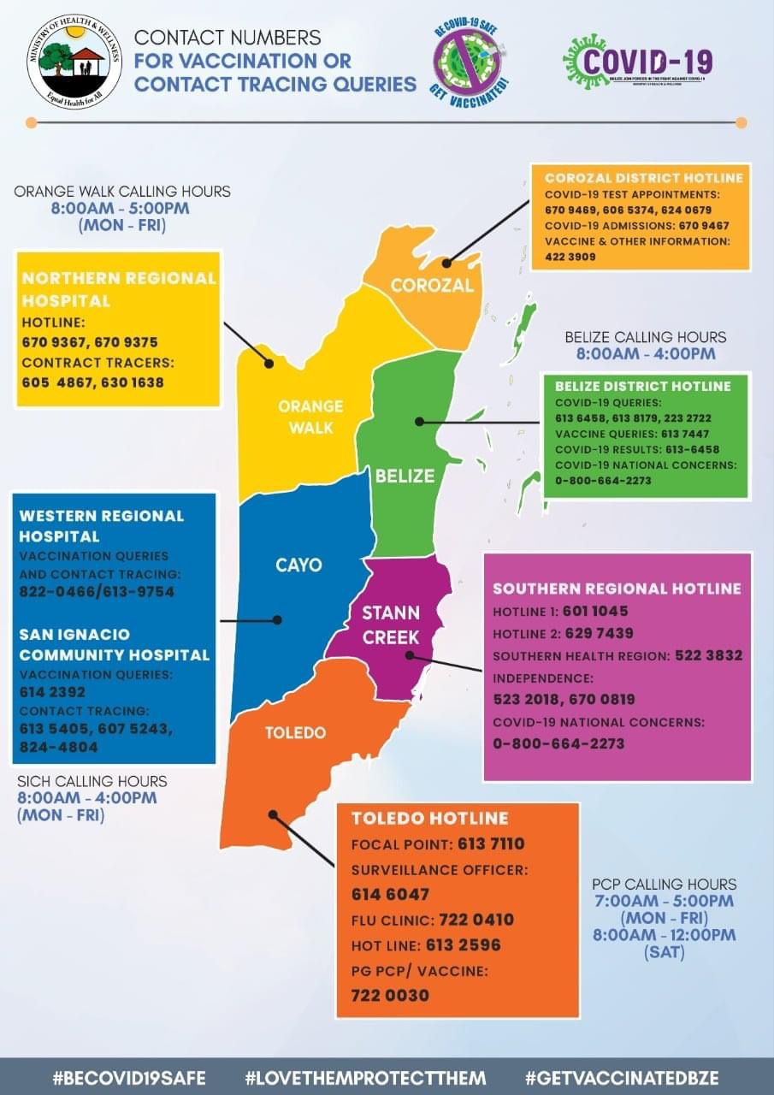

- For reference of reporting, the template below will be used to record any individual displaying symptoms, including elevated temperatures:

  - Templates of Log sheets used:
    - COVID-19 Symptomatic log
COVID-19 Symptomatic Log
Date | Guest or Employee name | Emergency contact information | Gender/Age | Symptoms observed | Place and time observed | Names of those in contact with symptomatic individual | Action taken

3) Ensure Social Distancing Protocols
- Social Distancing signage is placed in all key areas to remind guests of this COVID best practice. Below are pictures of social distancing in all of the below areas. (For reference ensure to include x markers with tape/ stickers to show standing areas and signage for guests where applicable.)
  - Place in strategic locations such as:
    - Reception area in office
    - Check in counters
    - Loading areas
    - Vehicle with partitions
    - Others that requires 6 ft distancing
Insert the images in the relevant areas
4) Implement Enhanced cleaning and Sanitization
Staff
  - All employees will be provided with access to hand sanitizer for daily use
  - All staff will wear masks and/or face shields
  - All staff will wear gloves when handling equipment

- Cleaning and sanitization logs will be kept for all areas of the tour operator. Below are logs for tracking of enhanced cleaning and sanitization. For reference use below samples or insert image if you already have logs.

Sample Logs
  - Cleaning and sanitization time log fleet

Vehicle/Vessel | Employee | Date | Time | Signature
Ex- Vehicle C-1967 | John Doe | Dec 10, 2020 | 5:15pm

  - Cleaning and sanitization for Equipment

Equipment | Employee | Date | Time | Signature
Snorkel masks | John Doe | Dec 10, 2020 | 5:15pm

  - Cleaning and sanitization for Office space

Area | Employee | Date | Time | Signature
Reception desk | John Doe | Dec 10, 2020 | 5:15pm

  - Cleaning and sanitization for Public Bathrooms

Area | Employee | Date | Time | Signature
Bathroom | John Doe | Dec 10, 2020 | 5:15pm

- Below is the general guidance for how to conduct enhanced cleaning and sanitization. For reference below are some suggestions or insert images of checklist for each area to be cleaned.
Enhanced Cleaning Checklist for areas being cleaned:
TERMINOLOGIES
Cleaning of visibly dirty surfaces followed by disinfection is a best practice measure for the prevention of COVID-19 in the community setting.
Cleaning
•Cleaning is a pre-disinfection step to remove dirt.
• Removes dust and debris from a surface/s.
• Action by scrubbing, washing and rinsing.
Sanitize
• Reduces the bacteria identified on the product’s label
Disinfection
• Destroys or inactivates both the bacteria and viruses identified on the product’s label
• EPA-approved disinfectant

Vehicle/Vessel Cleaning Checklist
Instructions:
- Personal hygiene regarding ‘cough etiquette’ and ‘hand hygiene’ must be observed.
- Keep cleaning products in the vehicle/vessel.
- Clean/ Disinfect all high touch points in the vehicle/vessel and remove all rubbish from vehicle at the end of the journey/Shift.
Note: Always ensure you wear correct Personal Protective Equipment

vehicle/vessel HIgh touch areas that require attention:
- Interior/Exterior door handles/knobs
- Window switches/handles/dashboard
- Air vents and controls
- Cup holders
- Radio Controls
- Steering wheel, hand brakes, gear shift
- Seatbelt Clips
- Keys and fuel cap
- Captain chair

Equipment Cleaning Checklist
Instructions:
- Gather all equipment’s used by guest/guides.
- Spray/wipe equipment with appropriate disinfectant and cleaning solution.
- Read solution label and apply as recommended.
- Clean and check condition of any equipment before returning to use.
- Allow to properly dry.
Note: Always ensure you wear correct Personal Protective Equipment

Equipment HIgh touch areas that require attention:
- Kayaks & Paddles
- Bicycles
- Flashlights
- Headlamps
- Helmets
- Fins
- Snorkeling gear
- Swimming vest

Office Area Cleaning Checklist (reception/check-in area)
Instructions
- Remove large debris from hard surfaces and floor.
- Empty trash cans and replace trash can liners, if needed. Wipe the outside.
- Dust file cabinets and counters, if needed.
- Clean high-touch point surfaces and other hard surfaces and disinfect as needed.
- Sweep carpets and hard floors, if needed.

Note: Always ensure you wear correct Personal Protective Equipment

OFFICE areas HIgh touch areas that require attention:
- Office door and doorknobs on both sides.
- Phone
- Computer Keyboard and Mouse
- High touch devices such as calculators, penholders
- Top and sides of the desk and everything on the desk (including coffee makers, mugs, etc.)
- Chair arm rests
- Light switch

Bathroom Cleaning Checklist
Instructions:
- Place work area warning sign.
- Pick up debris from floor.
- Empty trash cans and replace trash can liners, if needed. Wipe the outside.
- Clean high-touch point surfaces and other hard surfaces and disinfect as needed.
- Wipe and clean glass surfaces and windows, if needed.
- Check and refill soap and disinfectant dispensers, if needed.
- Clean and refill other amenities (e.g. paper towels, toilet paper).
- Wipe the floor, if needed.
Note: Always ensure you wear correct Personal Protective Equipment

Bathroom HIgh touch areas that require attention:
- Door handles/ knobs & handrails
- Sink faucets & toilet handles
- Soap & tissue dispenser handles
- Hand Dryer
- Stall door locks
- Trash can flips
- Surfaces of toilets & urinals
- All feminine product depositories
- Baby changing station (handle, surface, etc.)
- Wall tiles

- Disposal of waste
  - All employees will wear protective gloves and face masks when handling trash. Trash bins will be lined with bags and tied off securely when full.
  - All bags with possible contamination will be sealed in red bag and disposed separately.

5) Develop a Response Plan
- All staff must follow the following steps to deal with symptomatic guest and staff.
Kindly insert step by step response plan based on your operations. See samples below.

  - Check in at the office (If applicable)
    - Temporarily isolate staff/guest at (Insert temporary isolation area here) as soon as symptoms are observed.
    - Immediately contact the Program manager to report observations.
    - Program Manager will contact the MOHW for guidance.
    - Organize for transportation of guest/staff if advised after assessment by MOHW.
    - Update logs of COVID-19 case
    - Conduct cleaning and sanitization of areas as recommended.
    - log cleaning

  - Upon Pick Up (If applicable)
    - Temporarily isolate staff/guest at (Insert temporary isolation area here) as soon as symptoms are observed.
    - Immediately contact the Program manager to report observations.
    - Program Manager will contact the MOHW for guidance.
    - Organize for transportation of guest/staff if advised after assessment by MOHW.
    - Program Manager will contact Accommodation or Cruise Port.
    - Update logs of COVID-19 case
    - Conduct cleaning and sanitizing of vehicles and equipment used on tour
    - log cleaning

  - On tour
    - Temporarily isolate staff/guest at (Insert temporary isolation area here) as soon as symptoms are observed.
    - Immediately contact the Program manager to report observations.
    - Program Manager will contact the MOHW for guidance.
    - Organize for transportation of guest/staff if advised after assessment by MOHW.
    - Program Manager will contact Accommodation or Cruise Port.
    - update logs of COVID-19 case
    - disinfect and sanitize vehicles and equipment used on tour
    - log cleaning of all vehicles and equipment.

- Closest medical facility identified (Insert name and contact information)
    - _________________________________________
    - _________________________________________

- Additional notifications- Gold Manager(s) will assist guests with contacting their local diplomatic mission. This is often done to register their location and situation in a country if necessary. Should the guest(s) choose to contact the embassy directly they are free to use the local line. Should guest(s) request that the mission be contacted on their behalf then Management will request an electronic copy of their ID for verification purposes.

- Cleaning and disinfecting procedures after symptomatic guest departs:
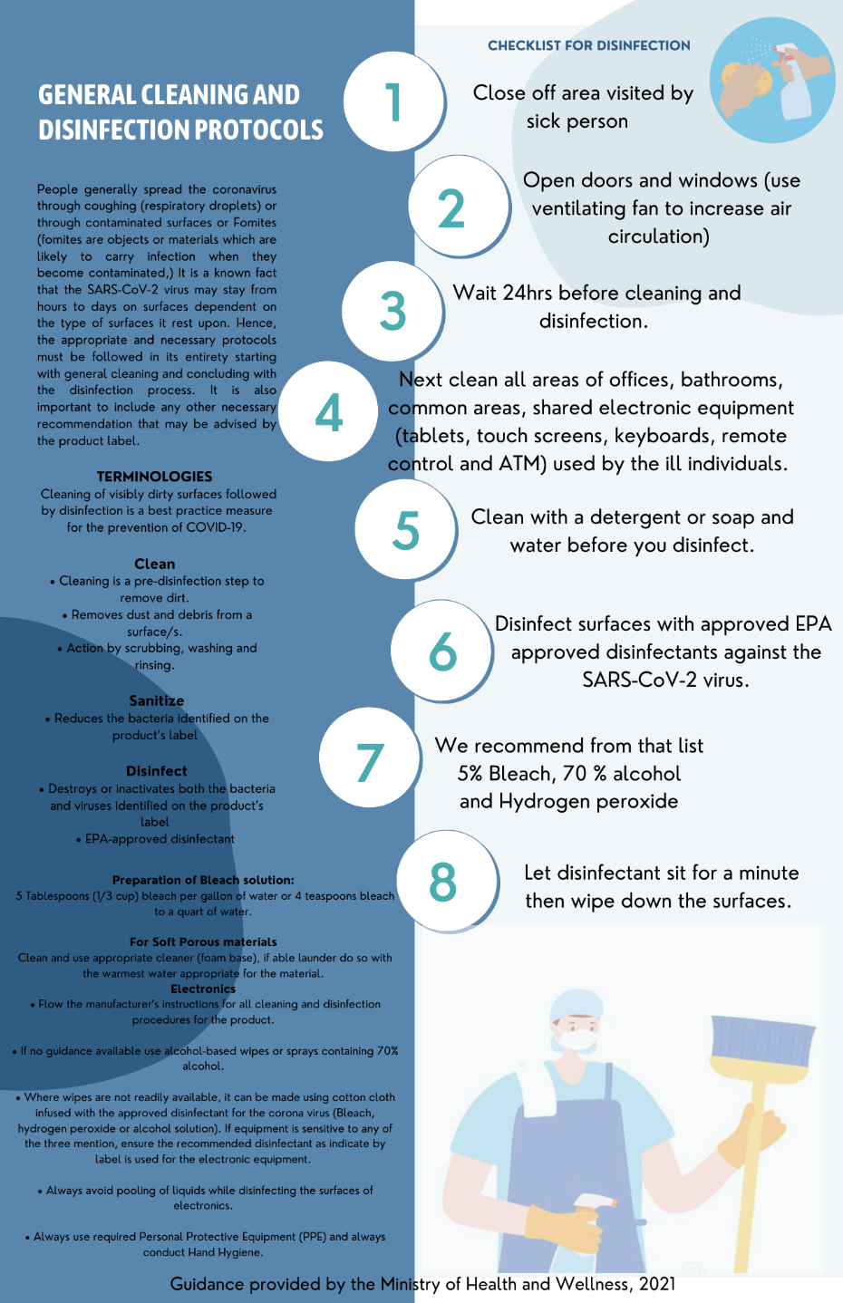

- See below inventory list of cleaning material, equipment and PPEs

ITEM
Insert list of cleaning material, equipment and PPE in stock.

- See below images of PPE and cleaning equipment
Insert images to correspond with your inventory

6) Ensure Clear and Consistent Communication
- Tour policies
- All tours will be executed with the safest measures in all efforts to reduce risk for guests and employees.
- Masks required at all times, with only exceptions:
    - On a high intensity tour where the guide is 6 feet apart. For example- hiking, rappelling.
    - Snorkeling
    - Once guest is seated in a restaurant to eat
    - Beach once sufficient distance is maintained from other guests.
- Booking will be flexible to accommodate payment reimbursements should a guest become symptomatic prior to tour and not able to take the tour.

- Guest Communication Plan
- Draft email that will be sent to guests to explain protocols, reimbursements and expectations on tour
Sample email
Dear Guest,
Thank you for your interest in taking a ______________tour with us. We are happy to inform you that our company is a Tourism Gold Standard Recognized Tour Operator Company; which means we have implemented all measures to mitigate any risks for our guests and employees.
What to expect on tour?
    - All tours will be guided by our expert and trained tour guides
    - Expect to have your temperature tested prior to tour departure.
    - Masks required at all times, with only exceptions:
        - On a high intensity tour where the guide is 6 feet apart. For example- hiking, rappelling.
        - Snorkeling
        - Once guest is seated in a restaurant to eat
        - Beach once sufficient distance is maintained from other guests.
    - Booking will be flexible to accommodate payment reimbursements should you become symptomatic prior to tour and not able to take the tour.
    - Ensure that your travel insurance covers medical care should you test positive in Belize. You will be required to cover all expenses associated with your care.
    - You must sign waiver accepting terms and conditions of tour
Thank you for your support and continued patience as we continue to work towards safely providing our services for you to enjoy our beautiful Belize. For more information on Belize’s entry requirements kindly visit: https://belizetourismboard.org/news-and-gallery/belize-covid-19-travel-updates/
Sincerely,
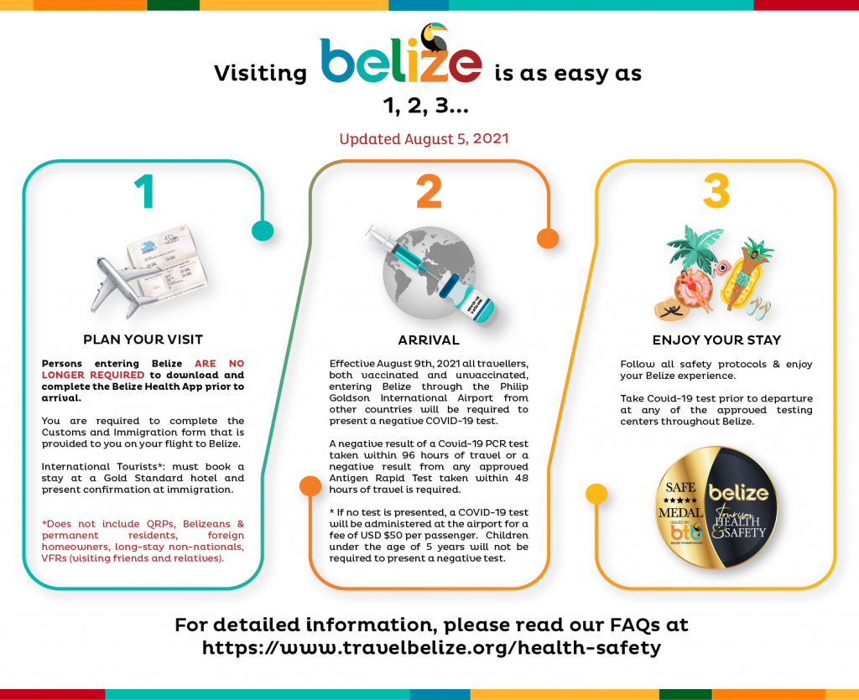

- Sample disclaimer- penalties of non-compliance with masks, cost of quarantine if positive, or any other liability clauses
Insert image

- Employee Communication below has been sent to all staff.
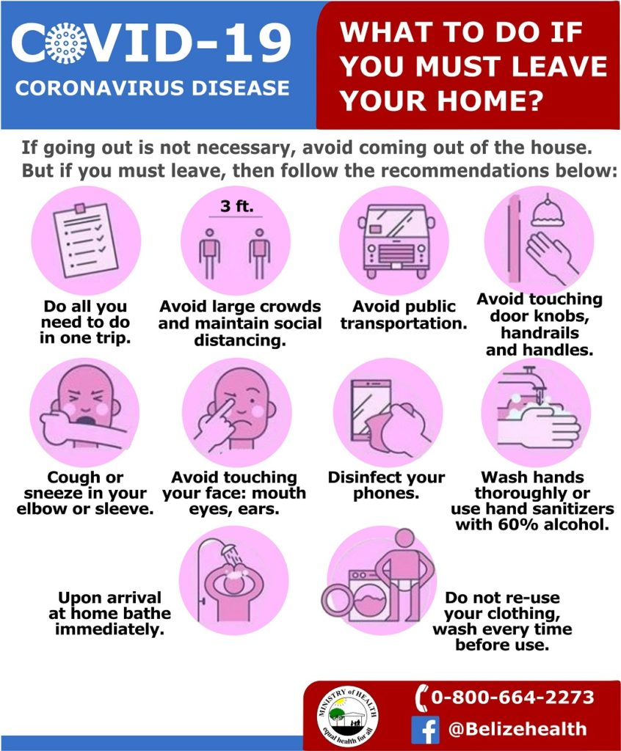

- Publicized Standard Operating Procedure will be shared via __________________________ (Insert website link, social media link or email address where applicable)

- To reinforce the Tour Operator COVID-19 protocols prior to guest arrival the following platforms are used to reinforce the message to guests: E.g. Email, Facebook, Online booking etc.
Insert image
- Signage
Below are images of signage around the tour office, vehicles, boats, loading areas (where applicable). (Signs of social distancing, proper hand washing and symptoms for constant reminders to guest and staff. See annex for samples)

Insert images installed in all relevant areas.
- See below information shared to guest that is contactless or can be sanitized.
(Insert image of laminated, digital or QR code of tour offering and prices, and any other information available that is contactless or can be sanitized.)

7) Install Sanitizing Stations
- See below images of sanitizing stations (installed equipment with soap dispensers, sanitizer gel, single use towels, etc) in all relevant areas (Office, Loading Area, Restroom, Boat, Vehicle, etc.)
Insert images and list location of sanitizing station

8) Deploy New Technology
- See below description and images of payment process (credit card, pre check-in credit card, website, online transfer, etc.)
Insert description and screenshots or images.

- See below description and images of pre-check in process such as digital ticketing, email confirmations, etc. (If applicable)
Insert description and images.

9) Implement a Training Plan
- All employees will be trained on the new protocols implemented. Training offered will be logged using the template below (Insert log if you have your own template). Images will also be kept for records. (Insert images if available)
Sample Training Log
Name of Training | Date attended | Staff Names | Signature

Annex- Sample Signage
